**DISEASE RECOGNITION SYSTEM FOR DOGS**

**TITLE: B FOR BARK**

**REQUIREMENT ANALYSIS**

**EXISTING SYSTEM**

System Name: petMD

petMD is the largest global source of pet health information in the world today. Part of a global network of veterinary professionals, petMD’s content was created by veterinarians for consumers and veterinarians. The content is written by veterinarians and approved by the veterinarian’s team. Hundreds of veterinarians, spanning eight countries across the world, were consulted, interviewed and enlisted to write, verify, and approve the content.

# petMD contains three basic functionalities:

# Search for pet health database

* Connect with a veterinarian and visit them often
* Discover new things that will inspire you to keep your pet healthy

**LIMITATIONS OF EXISTING SYSTEM**

Existing framework has a manual search which is hard for client. And furthermore there is no health card or unique id for each dog where the veterinarians can view the details related to the dogs whom they are currently treating and the previous history of the dog’s treatment.

**PROPOSED SYSTEM**

**Disease recognition system for dogs** is web based application where one can search for diseases related to dog according to the symptoms provided by the user. The audience for this system is huge as in today’s world every age group has easy access to internet and every other person is concerned about their pet’s health.

With this system they can just log in and check whether the symptoms visible are something to be given importance or not. This system could save lives if its accuracy is maximised and if it has a huge databank of diseases and its symptoms.

**BENEFITS OF PROPOSED SYSTEM**

Our system automatically searches and gives the outcome. In the Existing framework we have to manually search the details about the concerned disease which is not feasible for the user in most of the occasions.

* In our system we provide the user with the user friendly interface which gives substantially better outcome in detail.
* We also provide the details about the doctor, location of the concerned doctor and also the availability of the doctor.
* Furthermore, we are additionally exhibiting the trend analysis about the searched disease with a graphical portrayal.

**ERD DIAGRAM:**

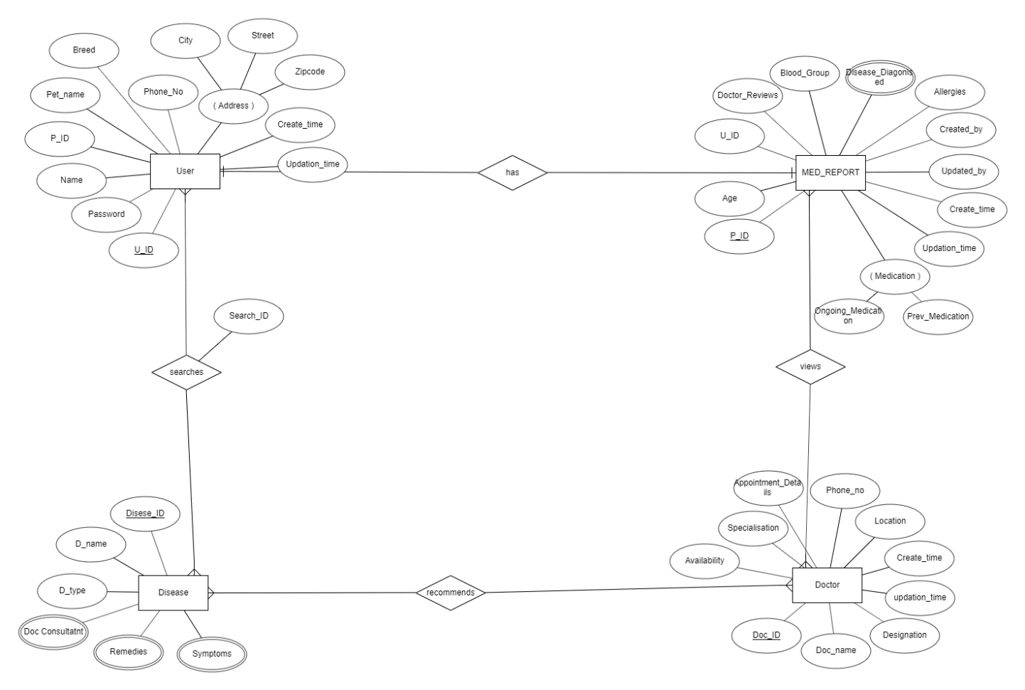

**LITERATURE SURVEY**

[Budimir Plavsic](https://www.researchgate.net/profile/Budimir_Plavsic) and [Drago Nedic](https://www.researchgate.net/profile/Drago_Nedic) has proposed Veterinary information management system (VIMS) in the process of notification and management of animal disease .The role of information system in animal disease diagnosis, surveillance and notification, control of national and international trade of commodities, food safety management, investigation of diseases, predictive microbiology and quantitative risk assessment is of great importance for the quality of veterinary service. Integral part of the VIMS is animal disease notification system designed according to and in compliance with international requirements, standards and recommendation and able to exchange relevant information with similar information systems. Some external systems, such as a laboratory information system, will ensure better control of animal diseases, improved system functionality, especially in establishing the sanitary status of individual animals, flocks, zones and compartments or the whole country, as well as the control of the trading of animals and animal products. The introduction of information systems into the veterinary system would ensure availability of accurate and reliable data for expert analysis, but also needed for improvement of quality management in the food chain. This would influence decrease of the number of outbreak in animal’s life cycle [1].

**REPORT ON THE CURRENT OR RECENT WORKS IN THE SELECTED TOPIC OF PROJECT WITH PROPER REFERENCES.**

The recent works on the project was proposed in the year 2009 the details related to this system is discussed in detail in the above literature survey.

**Reference**

[1] Plavsic, Budimir & Nedic, Drago & Micovic, Z & Tesic, M & Stanojevic, Slavoljub & Ašanin, Ružica & Krnjaic, Dejan & Tajdić, Nada & Milanovic, Sladjan. (2009). Veterinary information management system (VIMS) in the process of notification and management of animal diseases. Acta Veterinaria. 59. 10.2298/AVB0901099P.

**EXPLANATION OF THE SPECIALIZATION CONCEPTS USED**

* We are using the Google API’s to provide the doctor location.
* We are proving the trend analysis of recently searched diseases with the graphical representation.
* We are also providing the chat box for the user since
* A Live Chat Box Fulfils a Customer’s Need for Answers
* Chat allow users to assume the role or appearance of an avatar in a simulated or virtual reality environment.

**FUNCTIONAL REQUIREMENTS**

1. USER module
   1. Disease Search:

INPUT: Symptoms (multiple inputs can be given)

OUTPUT: The most relevant disease name predicted. Its quick remedies (if any), all symptoms and available doctors. Search ID and Disease ID

* 1. Symptom Search:

INPUT: Disease name.

OUTPUT: List of the symptoms of the disease, quick remedies (if any) and available doctors for it. Disease ID, Search ID

2. REGISTRATION module

2.1 Pet Register:

INPUT: Pet name, Breed, Blood group, allergies, previously diagnosed diseases…

OUTPUT: The health card (which will contain all the details of the pet) along with the pet ID.

3. SUGGESTED DOCTOR module:

3.1 Contact:

INPUT: Health card, Disease name and symptoms

OUTPUT: Appointment details and location.

4. DOCTOR module:

4.1 View health card:

INPUT: Pet ID

OUTPUT: Health Card

4.2 Search analysis

INPUT: from and to dates.

OUTPUT: Most browsed diseases and symptoms.

**ABSTRACT DESCRIPTION OF THE SYSTEM DEVELOPED**

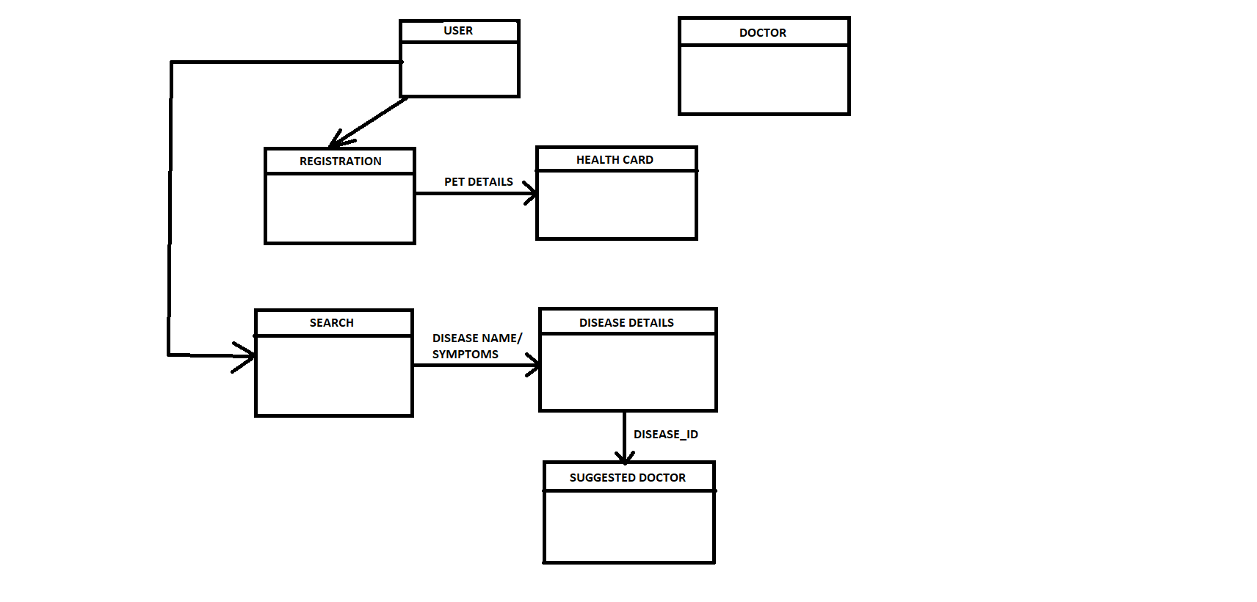

**DESCRIPTION OF MODULES**

1. **USER: -** This is the interface for the user concerned about their pets. One can search for disease according to symptoms or symptoms according to diseases. One would also be able to find quick remedies and the user will be provided with nearby doctor details where the user can book for appointments. This would also be user validating entry module requiring user name and password. Also the search data for each user will be saved for any further optimisations technique which could be used later in this project.
2. **REGISTRATION:** - The user will register for the details of the pet and according to the details a health card will be created for the ease of doctor to operate. Also, through the health card all the medical reports can be collected of the particular pet.
3. **DISEASE DETAILS: -** According to user’s input in search box details of the disease will be displayed or details of different symptoms of a disease will be displayed. As a result of the disease or symptom details our system suggests some doctor details for the user’s pet where the user can book an appointment with the available doctor at nearest location.